Assignment 4 : Create Stored procedure in Northwind database to insert or update a
record in a table

1. Create a stored procedure in the Northwind database that will calculate the average
value of Freight for a specified customer.Then, a business rule will be added that will
be triggered before every Update and Insert command in the Orders controller,and
will use the stored procedure to verify that the Freight does not exceed the average
freight. If it does, a message will be displayed and the command will be cancelled.

CREATE PROCEDURE spAvgFreight
@CustomerID nchar(5),
@AverageFreight REAL OUTPUT
AS
BEGIN
SELECT @AverageFreight = AVG(Freight) from Orders WHERE CustomerID = @CustomerID
END

Declare @AverageFreight REAL
EXECUTE spAvgFreight
'ROMEY',
@AverageFreight = @AverageFreight OUTPUT
select @AverageFreight as [answer];

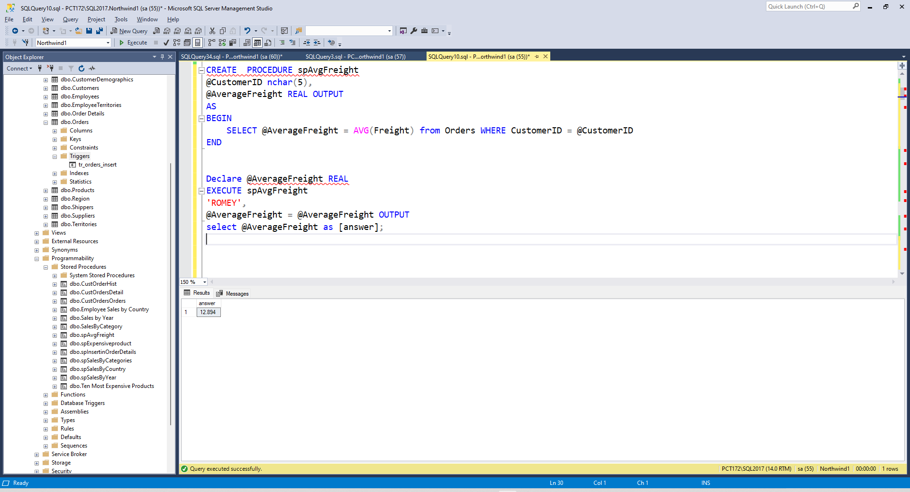

CREATE TRIGGER tr_orders_insert
ON Orders
INSTEAD OF INSERT
AS
BEGIN
DECLARE @cust nchar(5);
DECLARE @freight REAL;
SELECT @Cust = I.CustomerID FROM Orders O INNER JOIN inserted I ON O.CustomerID = I.CustomerID
SELECT @freight = I.Freight FROM Orders O INNER JOIN inserted I ON O.CustomerID = I.CustomerID

DECLARE @avg INT;

EXEC spAvgFreight
@CustomerID = @Cust,
@AverageFreight = @avg OUTPUT;

IF(@freight<@avg)
BEGIN
Print('Correct Value')

INSERT INTO Orders
SELECT CustomerID, EmployeeID, OrderDate, RequiredDate, ShippedDate, ShipVia, Freight, ShipName, ShipAddress, ShipCity, ShipRegion, ShipPostalCode, ShipCountry
FROM inserted

END
ELSE
BEGIN
Print('Wrong Value')
END
END
INSERT INTO Orders(CustomerID,EmployeeID,OrderDate,RequiredDate,ShippedDate,ShipVia,Freight,ShipName,ShipAddress,ShipCity,ShipRegion,ShipPostalCode,ShipCountry)
VALUES ('TEGC',4,'8/23/1996','9/20/1996','9/3/1996',1,100,'Reggiani Caseifici','Strada Provinciale 124','Reggio Emilia',NULL,'42100','Italy')
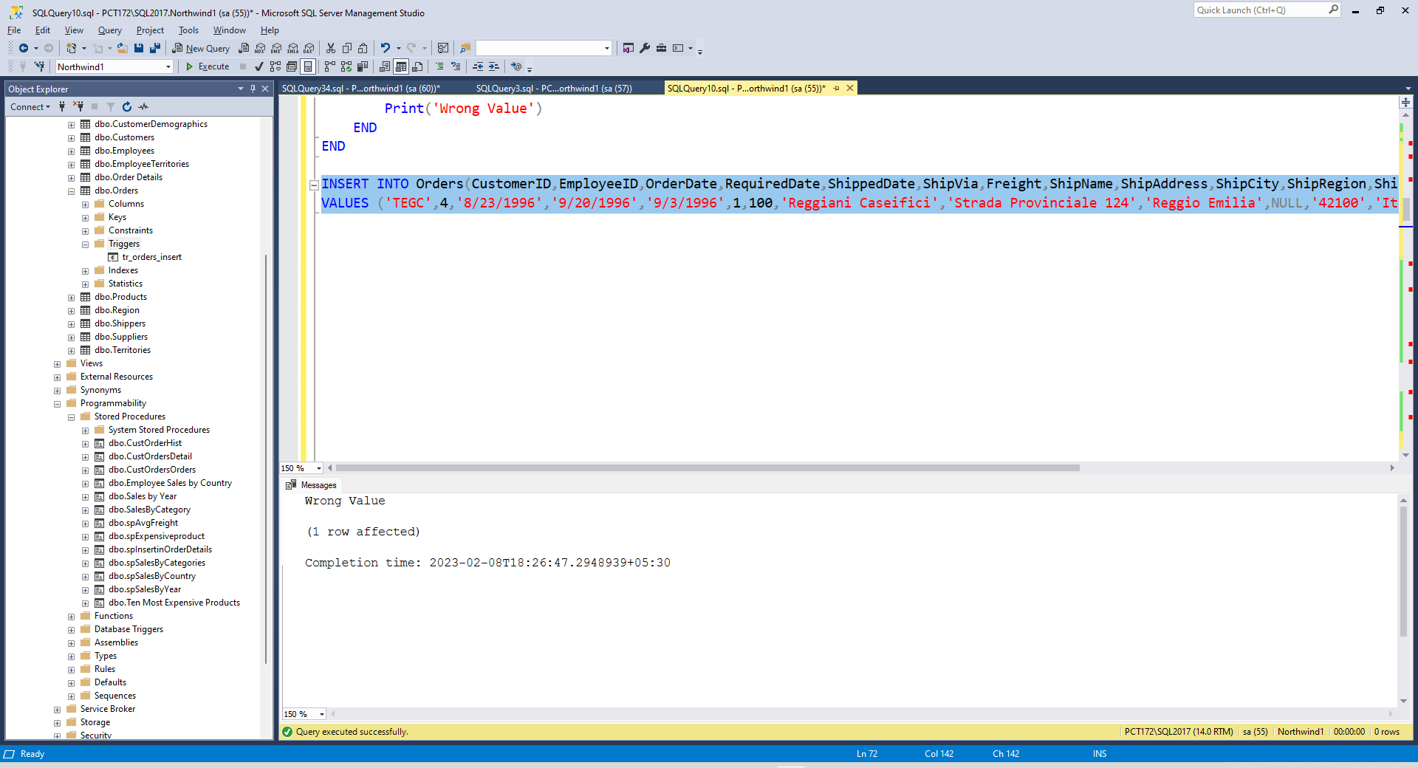
INSERT INTO Orders(CustomerID,EmployeeID,OrderDate,RequiredDate,ShippedDate,ShipVia,Freight,ShipName,ShipAddress,ShipCity,ShipRegion,ShipPostalCode,ShipCountry)
VALUES ('ROMEY',4,'8/23/1996','9/20/1996','9/3/1996',1,5,'Reggiani Caseifici','Strada Provinciale 124','Reggio Emilia',NULL,'42100','Italy')

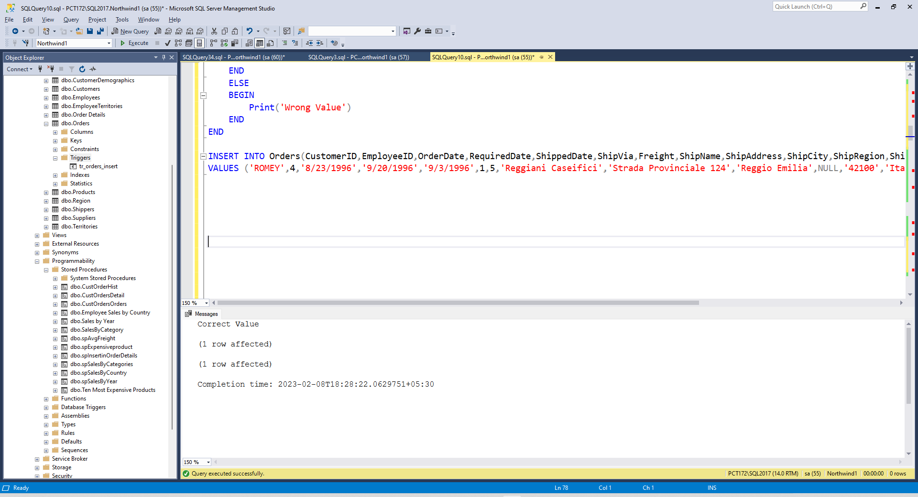

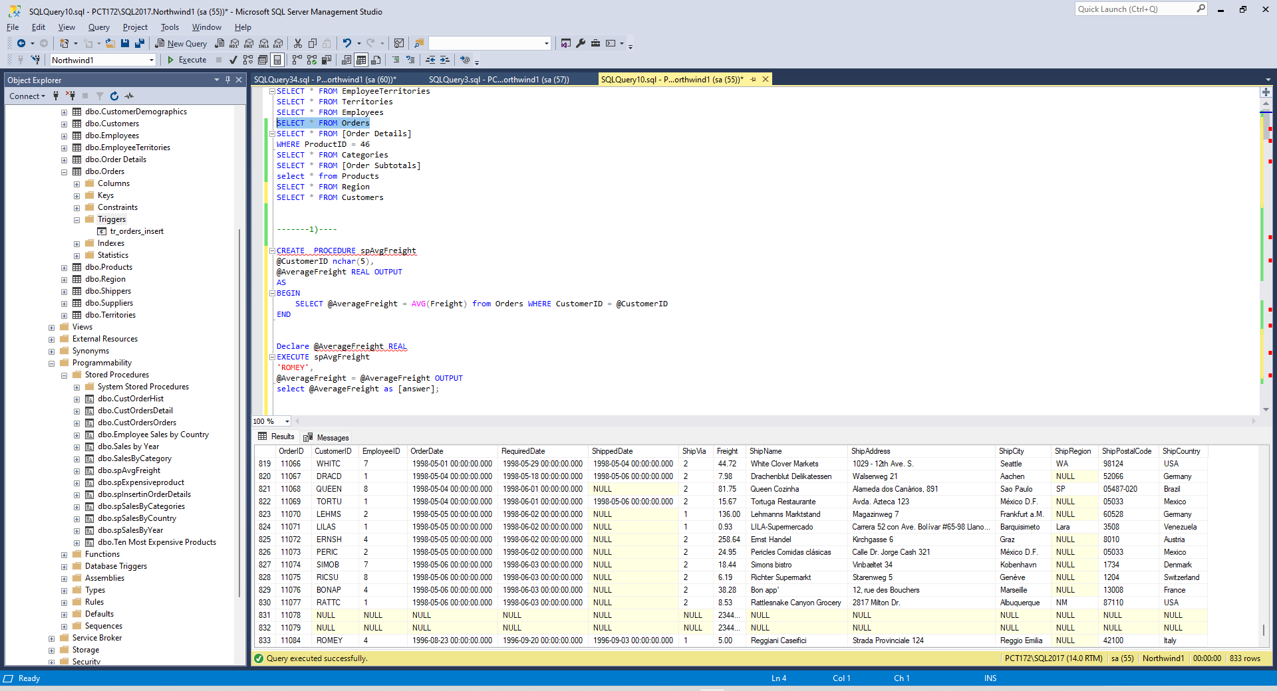

2. write a SQL query to Create Stored procedure in the Northwind database to retrieve
Employee Sales by Country

CREATE PROCEDURE spSalesByCountry
@country varchar(50)
AS
BEGIN
SELECT FirstName , LastName ,ShipCountry , SUM (Subtotal) Sales , COUNT(Orders.OrderID) [Total Orders]
FROM Orders
INNER JOIN Employees
ON Employees.EmployeeID = Orders.EmployeeID
INNER JOIN [Order Subtotals]
ON Orders.OrderID = [Order Subtotals].OrderID
WHERE ShipCountry = @country
GROUP BY ShipCountry , FirstName , LastName
ORDER BY FirstName

END

spSalesByCountry 'France'

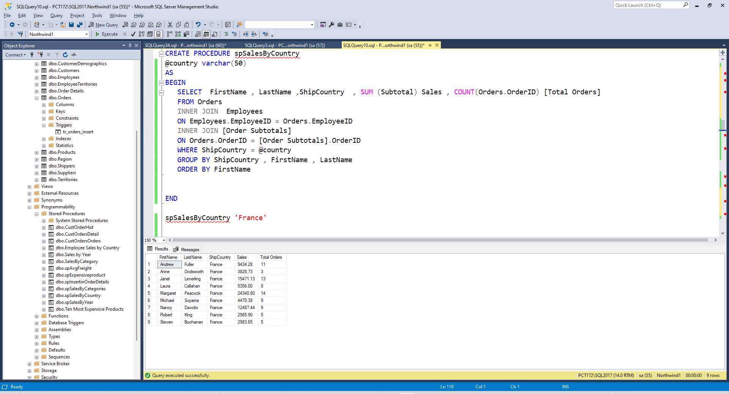
3. write a SQL query to Create Stored procedure in the Northwind database to retrieve
Sales by Year
CREATE PROCEDURE spSalesByYear
@choosestartdate DATETIME,
@chooseenddate DATETIME
AS
BEGIN
SELECT DATENAME(YYYY , ShippedDate), ProductName , TotalPurchase=ROUND(SUM(CONVERT(decimal(14,2), [Order Details].Quantity * (1-[Order Details].Discount) * [Order Details].UnitPrice)), 0)
FROM [Order Details]
JOIN Orders
ON [Order Details].OrderID = Orders.OrderID
JOIN Products
ON [Order Details].ProductID = Products.ProductID

WHERE ShippedDate BETWEEN @choosestartdate AND @chooseenddate

GROUP BY DATENAME(YYYY , ShippedDate) , ProductName
END
spSalesByYear
'1997',
'1998'

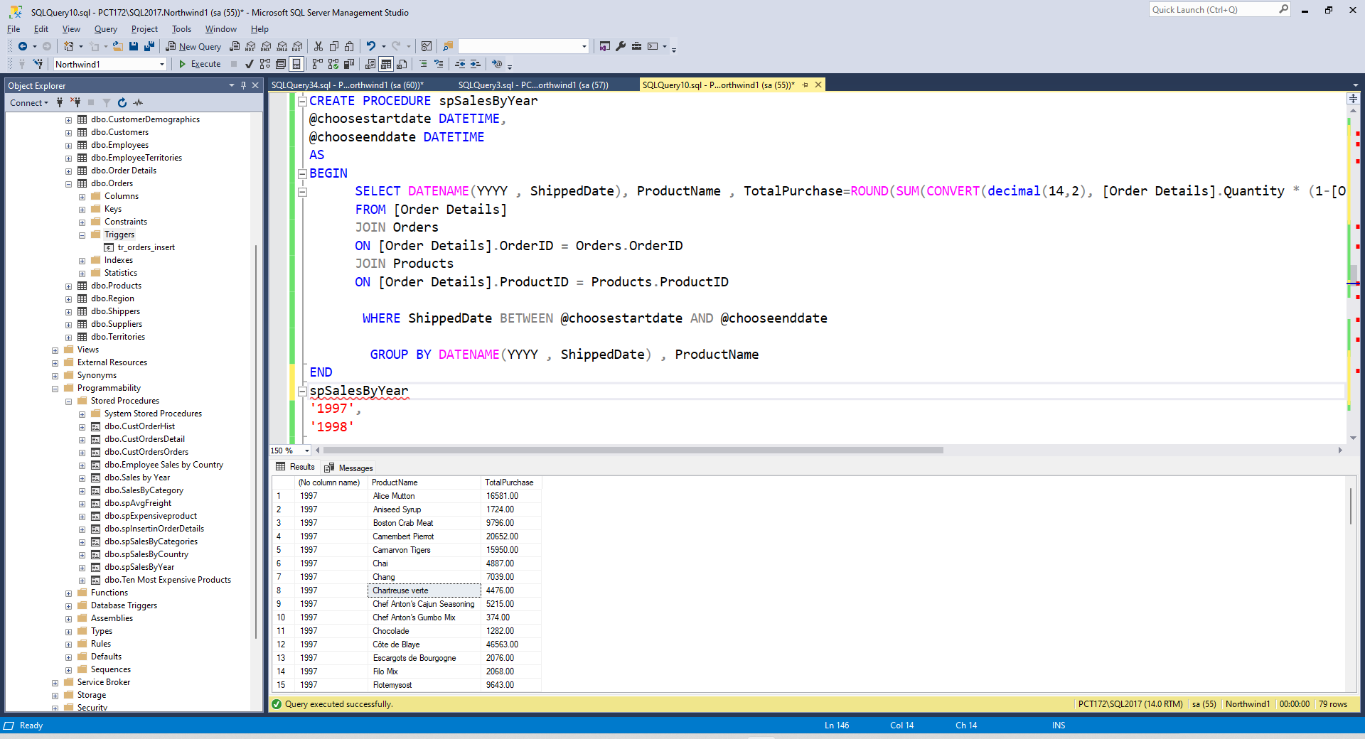
4. write a SQL query to Create Stored procedure in the Northwind database to retrieve Sales By Category
CREATE PROCEDURE spSalesByCategories
@CategoryName nvarchar(15)
AS
BEGIN
SELECT ProductName , TotalPurchase=ROUND(SUM(CONVERT(decimal(14,2), [Order Details].Quantity * (1-[Order Details].Discount) * [Order Details].UnitPrice)), 0)
FROM [Order Details]
JOIN Orders
ON [Order Details].OrderID = Orders.OrderID
JOIN Products
ON [Order Details].ProductID = Products.ProductID
JOIN Categories
ON Products.CategoryID = Categories.CategoryID

WHERE CategoryName = @CategoryName

GROUP BY ProductName
ORDER BY ProductName
END
spSalesByCategories
Seafood

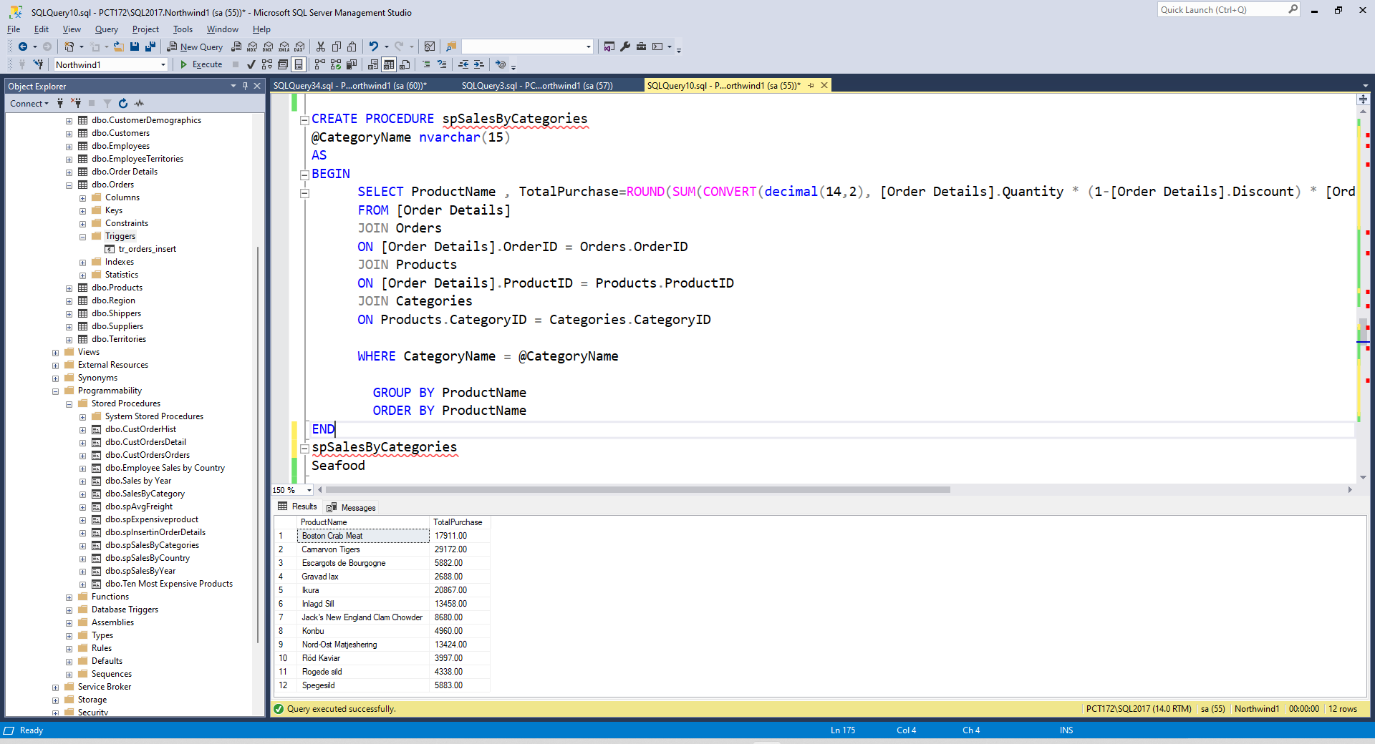
5. write a SQL query to Create Stored procedure in the Northwind database to retrieve Ten Most Expensive Products
CREATE PROCEDURE spExpensiveproduct
AS
BEGIN
SELECT TOP 10 * FROM Products ORDER BY UnitPrice DESC
END

spExpensiveproduct
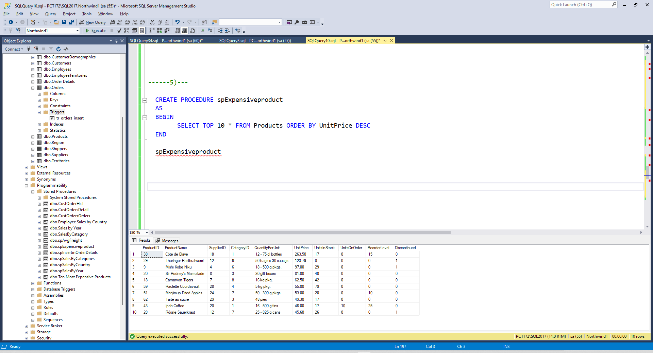

6. write a SQL query to Create Stored procedure in the Northwind database to insert
Customer Order Details

CREATE PROC spInsertinOrderDetails1
@CustomerID NCHAR ,
@EmployeeID INT,
@OrderDate DATETIME,
@RequiredDate DATETIME,
@ShippedDate DATETIME,
@ShipVia INT ,
@Freight MONEY,
@ShipName NVARCHAR,
@ShipAddress NVARCHAR,
@ShipCity NVARCHAR,
@ShipRegion NVARCHAR,
@ShipPostalCode NVARCHAR,
@ShipCountry NVARCHAR
AS
BEGIN

INSERT INTO Orders(CustomerID,EmployeeID,OrderDate,RequiredDate,ShippedDate,ShipVia,Freight,ShipName,ShipAddress,ShipCity,ShipRegion,ShipPostalCode,ShipCountry)
VALUES ('ROMEY',4,'8/23/1996','9/20/1996','9/3/1996',1,5,'Reggiani Caseifici','Strada Provinciale 124','Reggio Emilia',NULL,'42100','Italy')

END

spInsertinOrderDetails
@CustomerID = 'ROMEY' ,
@EmployeeID =4,
@OrderDate ='8/23/1996',
@RequiredDate ='8/23/1996',
@ShippedDate ='8/23/1996',
@ShipVia =12 ,
@Freight =7,
@ShipName ='Reggiani Caseifici',
@ShipAddress ='Reggiani Caseifici',
@ShipCity ='Reggiani Caseifici',
@ShipRegion ='Reggiani Caseifici',
@ShipPostalCode ='Reggiani Caseifici',
@ShipCountry ='Reggiani Caseifici'

